EENG 385 - Electronic Devices and Circuits

BJT Curve Tracer: Pseudo Ramp Generator

Lab Handout

# Objective

Analyze, assemble, and test a circuit which charges a capacitor through a resistor. Compare the RC charge curve to a straight line to determine if it is sufficiently close.

# System Architecture

Today, we will explore the Pseudo Ramp Generator, a circuit generating the ramp-shaped voltage waveform shown in Figure 1. Note, the inclined portion of the voltage waveform, the ramp, is slightly curved. This slight curve, this deviation from a straight line, defines the “Pseudo” in Pseudo Ramp Generator.

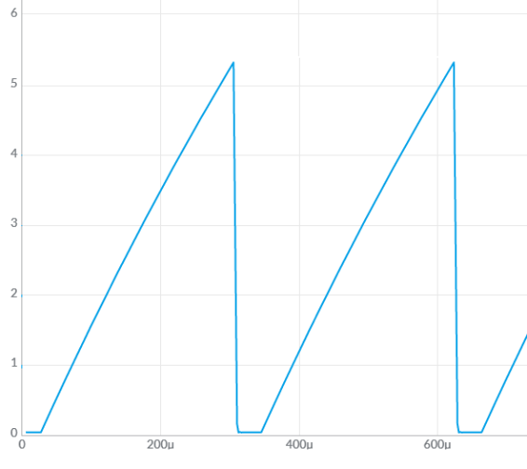

Figure 1: An example of the output the Pseudo Ramp Generator creates. Notice the slight curve in the ramp, this is result of charging a capacitor through a resistor.

We are now in our fourth lab analyzing, modeling, and constructing the various subsystems comprising the BJT Curve Tracer shown in Figure 2.

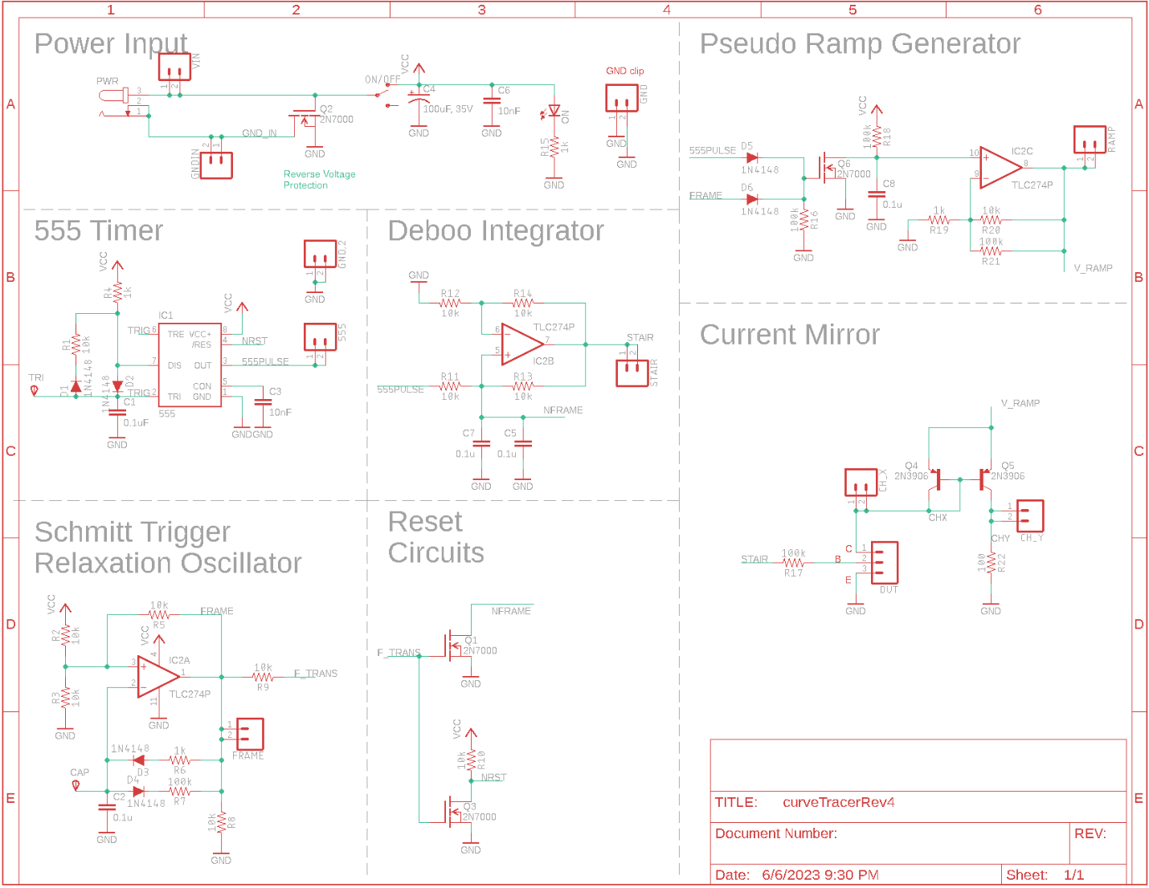

Figure 2: The complete BJT curve tracer.

Look carefully at the schematic shown in Figure 2 and locate the Pseudo Ramp Generator subsystem. Now, notice this subsystem is driven by the 555PULSE and FRAME signals. In order to understand the behavior of the Pseudo Ramp Generator, retrieve the simulation information you found in the previous labs and put it into Table 1.

Table 1: The output of the 555 Timer and Schmitt Trigger Oscillator simulations from the prior labs.

|  |  |  |
| --- | --- | --- |
| **Quantity** | **555 Timer Simulation** | **Schmitt Trigger Relax Osc Simulation** |
| Time high (µs) |  |  |
| Time low (µs) |  |  |
| Period (µs) |  |  |
| Frequency (kHz) |  |  |
| Duty Cycle |  |  |

We will come back to this table through the course of the lab.

# Analysis: Pseudo Ramp Generator

When plotted as a function of time, a ramp function has a constant slope measured as $\frac{∆V}{∆t}$. The term “Pseudo” is introduced into the name because the circuit to be built, shown in Figure 3, does not have a constant slope; it changes slightly as shown in Figure 1. To understand this further, let’s start the analysis of this circuit.

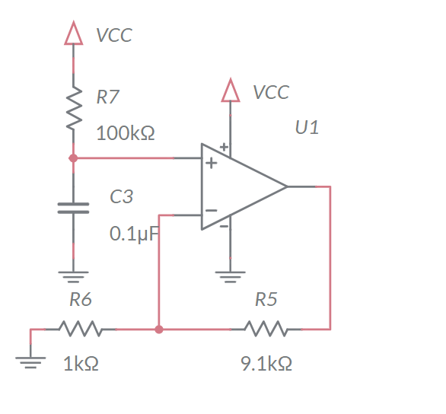

Figure 3: The Pseudo Ramp Generator circuit.

The analysis begins by recognizing the op amp configuration in Figure 3 is a non-inverting configuration. The resistors R5 and R6 form the feedback network. Note, the 9.1k resistor is formed from the parallel combination of 10k and 100k resistors. Why not just use a single 9.1k resistor? Two words, *inventory management* – it’s easier to manage the inventory of 1k and 100k resistors that are used in all sorts of PCBs, then it is to stock a wide variety of odd-ball resistor values that used just once.

1. Determine the gain of the non-inverting op amp in Figure 3.**Gain = 1+ R5 / R6 = 1+4.7 k/3.3 k = 2.42 V/V**
2. Determine the time constant for the RC network on the non-inverting input of the op amp in Figure 3. Remember that no current flows into an op amp input.

**R = 100 k C = 10 nf RC = 100*103 * 10*10-9 = 1000*10-6 sec**

1. Write an equation describing the voltage of the charging capacitor. Assume *VCC* = 9V.

**v(t) = 9*(1-e-t/1000µs)**

So, the output of the op amp in Figure 3 is the familiar exponential charging of an RC circuit. But how on earth will this be used to generate the ramp shape shown in Figure 1? Well, if we limit the charging to the very beginning of the exponential function, then we may get a sufficiently close to a straight line. In order to do this, we will need to limit the charging of the capacitor in Figure 3. We will do this by periodically removing the charge off the capacitor using the same technique used in the Deboo Integrator.

# Analysis: Pseudo Ramp Generator in BJT Curve Tracer

The Pseudo Ramp Generator will use a MOSFET to periodically remove the charge off the 0.1uF capacitor. The left-side of Figure 4 shows the schematic view of the MOSFET and capacitor from Figure 2.

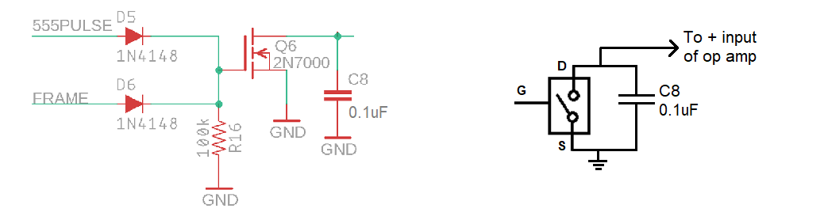

Figure 4: The schematic of a MOSFET/capacitor and its equivalent circuit for the Pseudo Ramp Generator.

We will reset the charge on the Pseudo Ramp Generator’s 0.1uF capacitor, using the MOSFET Q6 as a voltage-controlled switch, shown on the right-side of Figure 4. The behavior of this switch is the same as the previous lab, and given by:

* When the gate is driven towards 9V, the switch is closed.

In other words, the drain **and** source are **connected**.

* When the gate is driven towards 0V, the switch is open.

In other words, the drain **is disconnected** from the source.

Observe, the gate of the MOSFET in Figure 4 is driven by both the 555PULSE and FRAME signals through diodes. Let’s take a moment to focus on the purpose of the diodes D5, D6. In this analysis, you will use the ideal diode model which is defined by the following two bullet points.

* If the diode is forward biased (anode wants to be at a higher potential than the cathode), then the diode is a short circuit.
* If the diode is reverse biased (cathode wants to be at a higher potential than the anode), then the diode is an open circuit.

Use this model to determine the gate voltage and capacitor behavior for every combination of 555PULSE and FRAME voltage shown in Table 2. To help you get started, consider what happens in the FRAME=9V, 555PULSE=0V cell.

*Diode D6 is forward biased because its anode is at 9V and the cathode is attached to ground through the resistor R16. Thus, the gate of the MOSFET is at 9V. This situation causes the MOSFET to act like a closed switch, connecting the drain of the MOSFET to the source. This closed switch causes any charge on the 0.1F capacitor to discharge. Diode D5 is reverse biased because its cathode is at a higher potential than its anode. So, diode D5 acts like an open circuit.*

Table 2: The behavior of the MOSFET when driven by the two diodes.

|  |  |  |
| --- | --- | --- |
| 555PULSE\FRAME | FRAME = 0V | FRAME = 9V |
| 555PULSE = 0V | Gate = 0V  Capacitor is charging | Gate = 9V  Capacitor is discharged |
| 555PULSE = 9V | Gate = 9V  Capacitor is discharged | Gate = 9V  Capacitor is discharged |

The pair of diodes acts like a logic gate. Let 0V represent logic 0 and 9V represent logic 1.

1. What logic gate does the pair of diodes form when you consider 555PULSE and FRAME as the input and the MOSFET gate as the output?

**The pair of diodes forms an OR gate because when either the 555PULSE or FRAME inputs is at logic 1, the GATE is also at logic 1.**

Now let’s put these ideas together into a picture of how the waveform generated by the Pseudo Ramp Generator will look in the simulator and when assembled.

1. During one period of the 555PULSE signal, how long will the 0.1uF capacitor in the Pseudo Ramp Generator by held at 0v? Assume the FRAME signal is at 0V.

**The 10nF capacitor will be held at 0V while the 555PULSE signal is at 9V. The 555PULSE is at 9V for 39 µs.**

1. During one period of the 555PULSE signal, how long will the 0.1uF capacitor in the Pseudo Ramp Generator be allowed to charge? Assume the FRAME signal is at 0V.

**The 10nF capacitor will be allowed to charge while the 555PULSE signal is at 0V. The 555PULSE is at 0V for275 µs.**

1. Assume that the 0.1uF capacitor is totally discharge. During one period of the 555PULSE signal, what is the highest voltage the 0.1uF capacitor will obtain? Assume the FRAME signal is at 0V.

**During one period of the 555PULSE waveform, the waveform will be at 0V for 275 µs.**

***v(t) = 9*(1-e-275us/1000us) = 2.16V***

1. Using the same assumptions as in the previous problem, what will be the highest voltage on the op amp output? *(Hint: Multiply the previous answer by the gain of the op amp found in an earlier question.)* Put this answer in the Analysis column of Table 3 at the end of the lab.

***2.16V * 2.42 = 5.24V***

The reason the FRAME signal in this circuit is because the FRAME pulse resets the 555 Timer via the NRST signal. This 555 reset stops the 555 Timer from generating pulses and consequently stops the 555PULSE signal from clearing the charge off the 0.1uF capacitor. So, when the 555 Timer is in reset due to the FRAME signal, the FRAME signal is responsible for clearing the charge off the 0.1uF capacitor.

So now we know how much of the charging exponential function we are using to approximate a straight line. The next question to address becomes: Is this part of the exponential charging of the capacitor straight enough? Let’s examine the question further.

Let’s compare the exponential curve against a straight line using the rampVsCharge.xlsx spreadsheet posted on the Canvas page. When you open the spreadsheet, its contents will look like Figure 5. You need to complete two tasks with this spreadsheet. First, enter the equation for the charging capacitor in (R7 and C3 in Figure 3) the green cells. Second, adjust the value of Delta V in the orange cell to best match the charging capacitor.

To perform these two tasks you need to understand what the values in the spreadsheet mean.

* The **Time** values in column B are times in seconds. Note that the column spans 0us to 888us which is the charging time of the capacitor C3 in Figure 3. Each row is the Time column is Delta T larger than the row above it. The value of Delta T is set in cell C2. Don’t change this value!
* The **Ramp** values in column C are voltage values of a ramp function that has a slope given in cell C4 (which is equal to Delta V/Delta T or C3/C2). You will modify orange cell C3 to change the slope of the ramp in order to minimize the difference between the ramp and the RC charge.
* In the green cell C5, enter the RC time constant found in Step 2 of the Analysis Pseudo Ramp Generator section. Write 10-3 as “1e-3”. So, to put the value 32.3*10-3 in a cell, type 32.3e-3.
* The **Charge** values in column D will contain the voltage values of the exponential charging function whose time constant is in cell C5 at the times given in column B. To do this, place the equation for the charging capacitor (Analysis Pseudo Ramp Generator section, question 3) above into cells D11 – D32. Here are some tips to get Excel to help you do this.
  + Use the “=” sign to start a mathematical expression.
  + Write the expression e-2 “= EXP(-2)”.
  + To reference the time, use the letter-column references at the top of the page and the numerical-row references found on the left margin. For example, in cell D12 you can type “=B12” and the value of the time in cell B12 will be placed in cell D12.
  + The reference to the RC time constant in C6 should have “$”s in front of the C and 6, to reference this *specific* cell when we copy the equation down in the D column. In other words, “=$C$6” will reference cell C6 regardless where you copy the equation.
  + Once you have the equation typed in cell D12, copy it into all the relevant cells in column D by left-clicking on the green handle in the lower right of cell D12 and dragging downward all the way to cell D29.

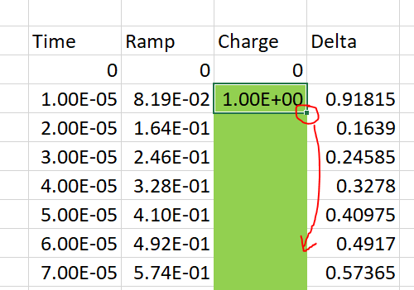

* + Once you have the exponential equation entered correctly, the orange Charge graph will appear in the “Ramp and Cap Charging vs. Time” graph and the Delta graph will look different. Note, the voltage of the charging capacitor at 888us in your Excel plot should equal the answer that you got in Question 3.
* The Delta values in column E are the absolute value of the difference between the value in column C and column D, that is, the difference between the line and the exponential function. Adjust the orange cell C4 to minimize the largest delta value. The graph titled “Deviation from a Ramp” in the Excel file will help you do this.
* Record the value of Delta V that minimizes the largest value of Delta, and the value of that Delta value in your solution. You will also be asked for your Ramp and Cap Charge vs. Time graph in your solutions.

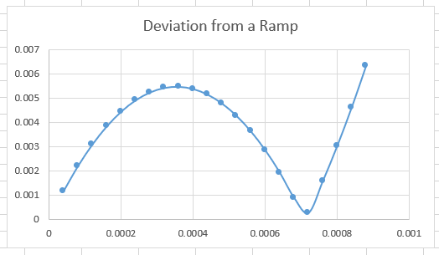***Vfinal = 2.23V for which Delta =0.054V***

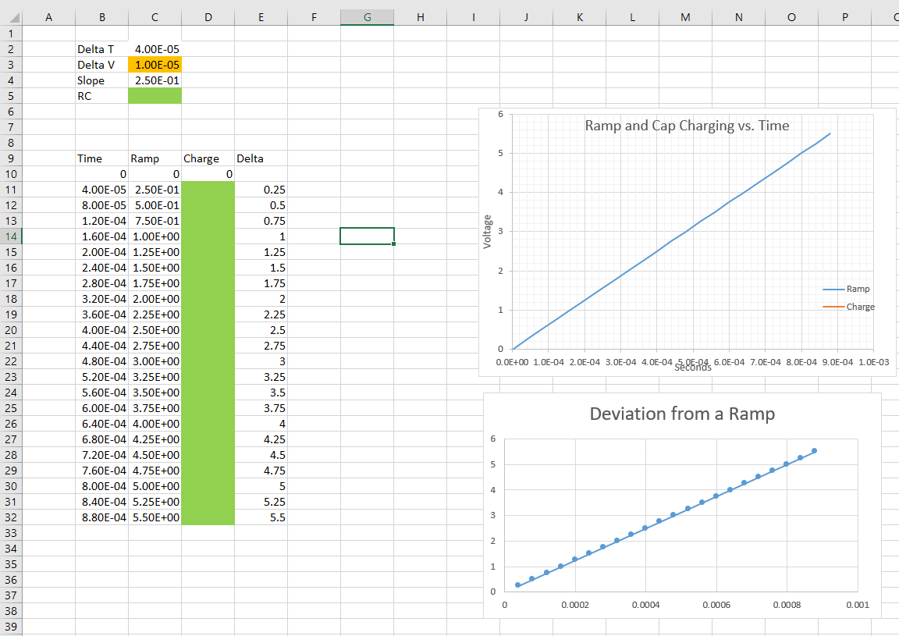

Figure 5: (Left) Spreadsheet to compare exponential charging against a straight line. (Right) When I finished the spreadsheet, I found very close agreement between the ramp and exponential charging.

From the previous work in Excel, you should be fairly confident the Pseudo Ramp Generator circuit will generate a reasonably straight line. So, let’s simulate it.

# Simulation: Pseudo-Ramp Generator

Use the skills you learned last week to build the circuit shown in Figure 6. Start by making a copy of the 555 Timer circuit from Lab 1, rename the file, and then add the circuit elements in Figure 6.

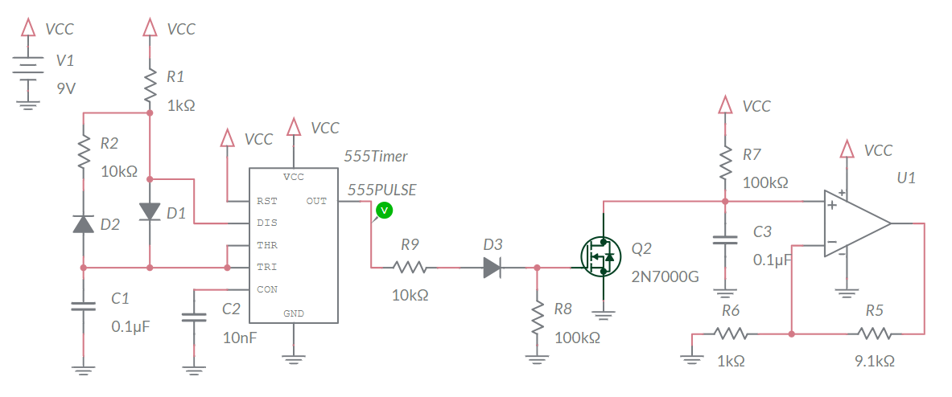

Figure 6: The charging capacitor in the Pseudo Ramp Generator is periodically reset by the 555 Timer.

Build the circuit in Figure 6. Make set to change the ABSTOL parameter to 1e-8 like you did for the Deboo Integrator lab. After building the circuit, run the simulation for 2ms and include the simulated waveform with your answers. To do this, make sure to Zoom All and use the Export -> Grapher image from the main menu to produce an output graphic.

Enter the highest voltage produced on the RAMP in the **Simulation** column of Table 3 at the end of the lab.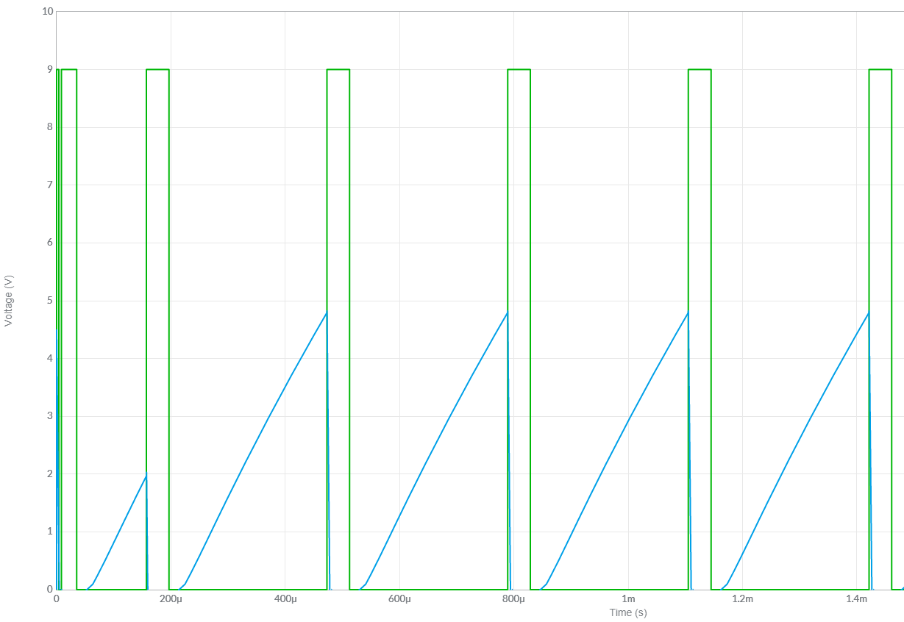

# Empirical: Pseudo Ramp Generator

Once you have completed assembly of your PSEUDO RAMP GENERATOR subsystem, perform the following test.

1. Power up an oscilloscope, attach a probe to Channel 1 and configure it as follows.

|  |  |
| --- | --- |
| Ch1 probe | 555 test point |
| Ch1 ground clip | GND test point |
| Horizontal (scale) | 500us |
| Ch1 (scale) | 2V |
| Ch2 probe | RAMP test point |
| Ch2 (scale) | Same as Channel 1 |
| Trigger mode | Auto |
| Trigger source | Ch1 |
| Trigger slope | ↑ |
| Trigger level | 4.5V |

1. Set the GND reference of Ch1 and Ch2 to the lowest visible reticule. The waveforms will overlap the same as they did in the MultiSim simulation. Set the horizontal position of the trigger to the left most visible reticule. Take a screen shot of this output and include it in your lab report.
2. Take a screen shot of the of the 555PULSE and RAMP waveforms and include them in your lab report. Screen shot the oscilloscope traces on USB. Cell phone pictures will lose points.  
   [Save] → Save → Format → 24-bit Bit... (*.bmp) [Save] → Save → Press to Save

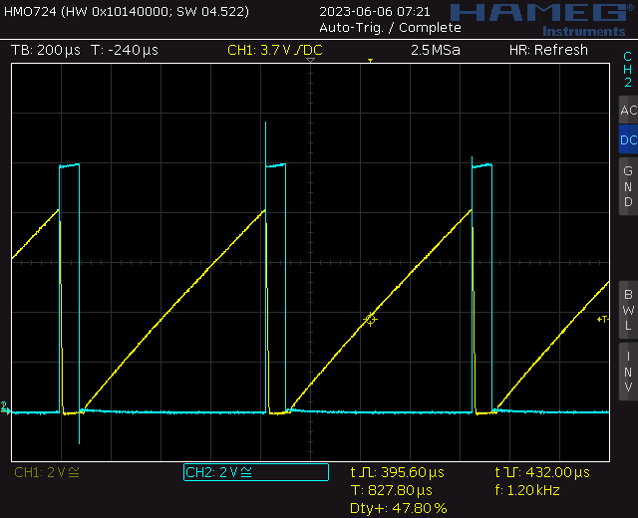

Figure 8: An oscilloscope trace showing the two output you need to capture. Note that this image was captured on a Rhode&Schwarz HMO724.

# Comparison: Pseudo Ramp Generator

Complete the **Analysis, Simulation** and **Empirical** columns of the following tables using the information you found throughout this lab. Represent your answer to 3 significant figures using the units given in parenthesis in the **Quantity** column. You will need this table in later labs, so keep it handy.

Table 3: Summary of the voltage produced by the Pseudo Ramp Generator.

|  |  |  |  |
| --- | --- | --- | --- |
| **Quantity** | **Analysis** | **Simulation** | **Empirical** |
| Ramp Amplitude (volts) |  | 5.34V | 5.64V |

# Turn In: Pseudo Ramp Generator

1. Make a record of your response to numbered items below and turn in a single copy as your team’s solution on Canvas using the instructions posted there.
2. Include the names of both team members at the top of your solutions.
3. Use complete English sentences to introduce what each of the items listed below is and how it was derived.

Hint, use Ctrl+click to follow links. This also works for all the Figures and Tables in these labs.

**Analysis: Pseudo Ramp Generator**

Steps 1 – 3 of analysis

**Analysis: Pseudo Ramp Generator in BJT Curve Tracer**

Table 2

Steps 1 – 5 of analysis

Ramp and Cap Charge vs. Time graph from Excel

Value of *Vfinal* and the largest value of Delta

**Simulation: Pseudo Ramp Generator**

Schematic (use Export -> Schematic Image)

Timing diagram (use Export -> Grapher Image)

**Assemble: Pseudo Ramp Generator**

Screen shot oscilloscope output for 555PULSE and RAMP.

**Comparison: Pseudo Ramp Generator**

Table 3 Compare Pseudo Ramp Generator output in different models.